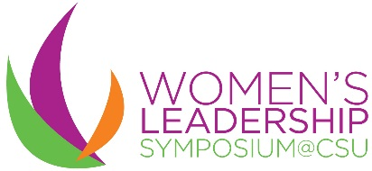
For more information about the Women’s Leadership Symposium, visit http://www.csualumni.com/wls or call 216-687-2078
Diamond: $15,000
Presenting Sponsor
Ex. CSU Women’s Leadership Symposium presented by GCA Services Group
-Company logo in the title, all promotional materials, all web-based materials and all event signage
-Opportunity to say a few words prior/post Keynote Address
-Company logo displayed prominently on the stage all day
-Company logo listed on the WLS homepage banner, on the sponsorship page and include company link
-Company logo on front of the event program and on the back cover
-Company logo on the screens in Wolstein as guests arrive
-Free skirted table at the sponsorship expo

Emerald: $10,000
Keynote sponsorship
-Company logo in all promotional materials, all web-based materials and all event signage
-Opportunity to say a few words prior/post Keynote Address
-Company logo displayed prominently on the stage all day -Company logo listed on the WLS home page banner, on the sponsorship page and include company link
-Company logo on the event program
-Company logo on the screens in the Wolstein Center as guests arrive
-Free skirted table at the sponsorship expo

Crystal: $7,500
Lunch sponsorship
-Signage near the lunch buffet with company logo
-Opportunity to say a few words prior/post Lunch
-Company logo listed on the sponsorship page and include company link
-Company logo on the event program
-Company logo on the screens in Wolstein as guests arrive
-Free skirted table at the sponsorship expo

Opal: $2,500
Individual breakout Sessions/Industry Panels and Coffee Bar
-Opportunity to give a quick “commercial” about the company and to introduce the speaker for the session
-Company logo on the breakout signage outside of the session
-Company logo listed on the sponsorship page and include company link
-Company logo on the event program
-Literature distributed on or near the coffee bars
-Company logo listed on the sponsorship page and include company link
-Company logo on the event program

Sponsor a Cleveland State University student: $70
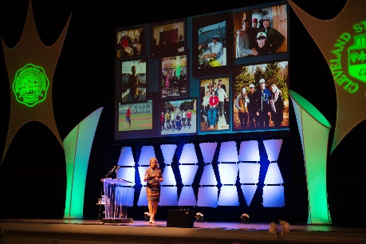

Sponsorship Reservation Form

Name of Company____________________________________________________________
Address____________________________________ City__________ State____ ZIP_______
Contact Name_____________________________ Phone_____________________________
Email_____________________________
Sponsor Level – Check
Diamond: $15,000 ____ Emerald: $10,000 ____
Crystal: $7,500 ____ Opal: $2,500 ___

Sponsor a Cleveland State University student: $70 ___

Tickets to attend:
Alumnae, Faculty and Staff: $50___
Community Member: $60___
Students: FREE

Credit Card Number________________________________ Exp Date________ CCV_______
Checks can be made payable to:
Cleveland State University Alumni Association
2121 Euclid Avenue, MM 203
Cleveland, OH 44115

